Faisal Qaderi

**FORTNITE**



## Research question and data Sourcing

I founded this Data set in Kaggle as I am a big fan of Fortnite and how the game became so popular however after playing it for so many years I was thriving to be the top 50 at least but unfortunately, I could not make it. but this did not stop me from researching and finding out what elements help. The best players in the world to be at the top 50. This is why the research question is:

“How do the top 50 solo players in Fortnite perform in just one game mode, and what elements help them on their success? “

**REFERENCE**

Data source = Kaggle

Data link = <https://www.kaggle.com/datasets/iyadali/fortnite-players-stats>

By IYAD MOHAMED FOUAD ALI.

Last accessed 12th December 2023

Uploaded and updated 2021

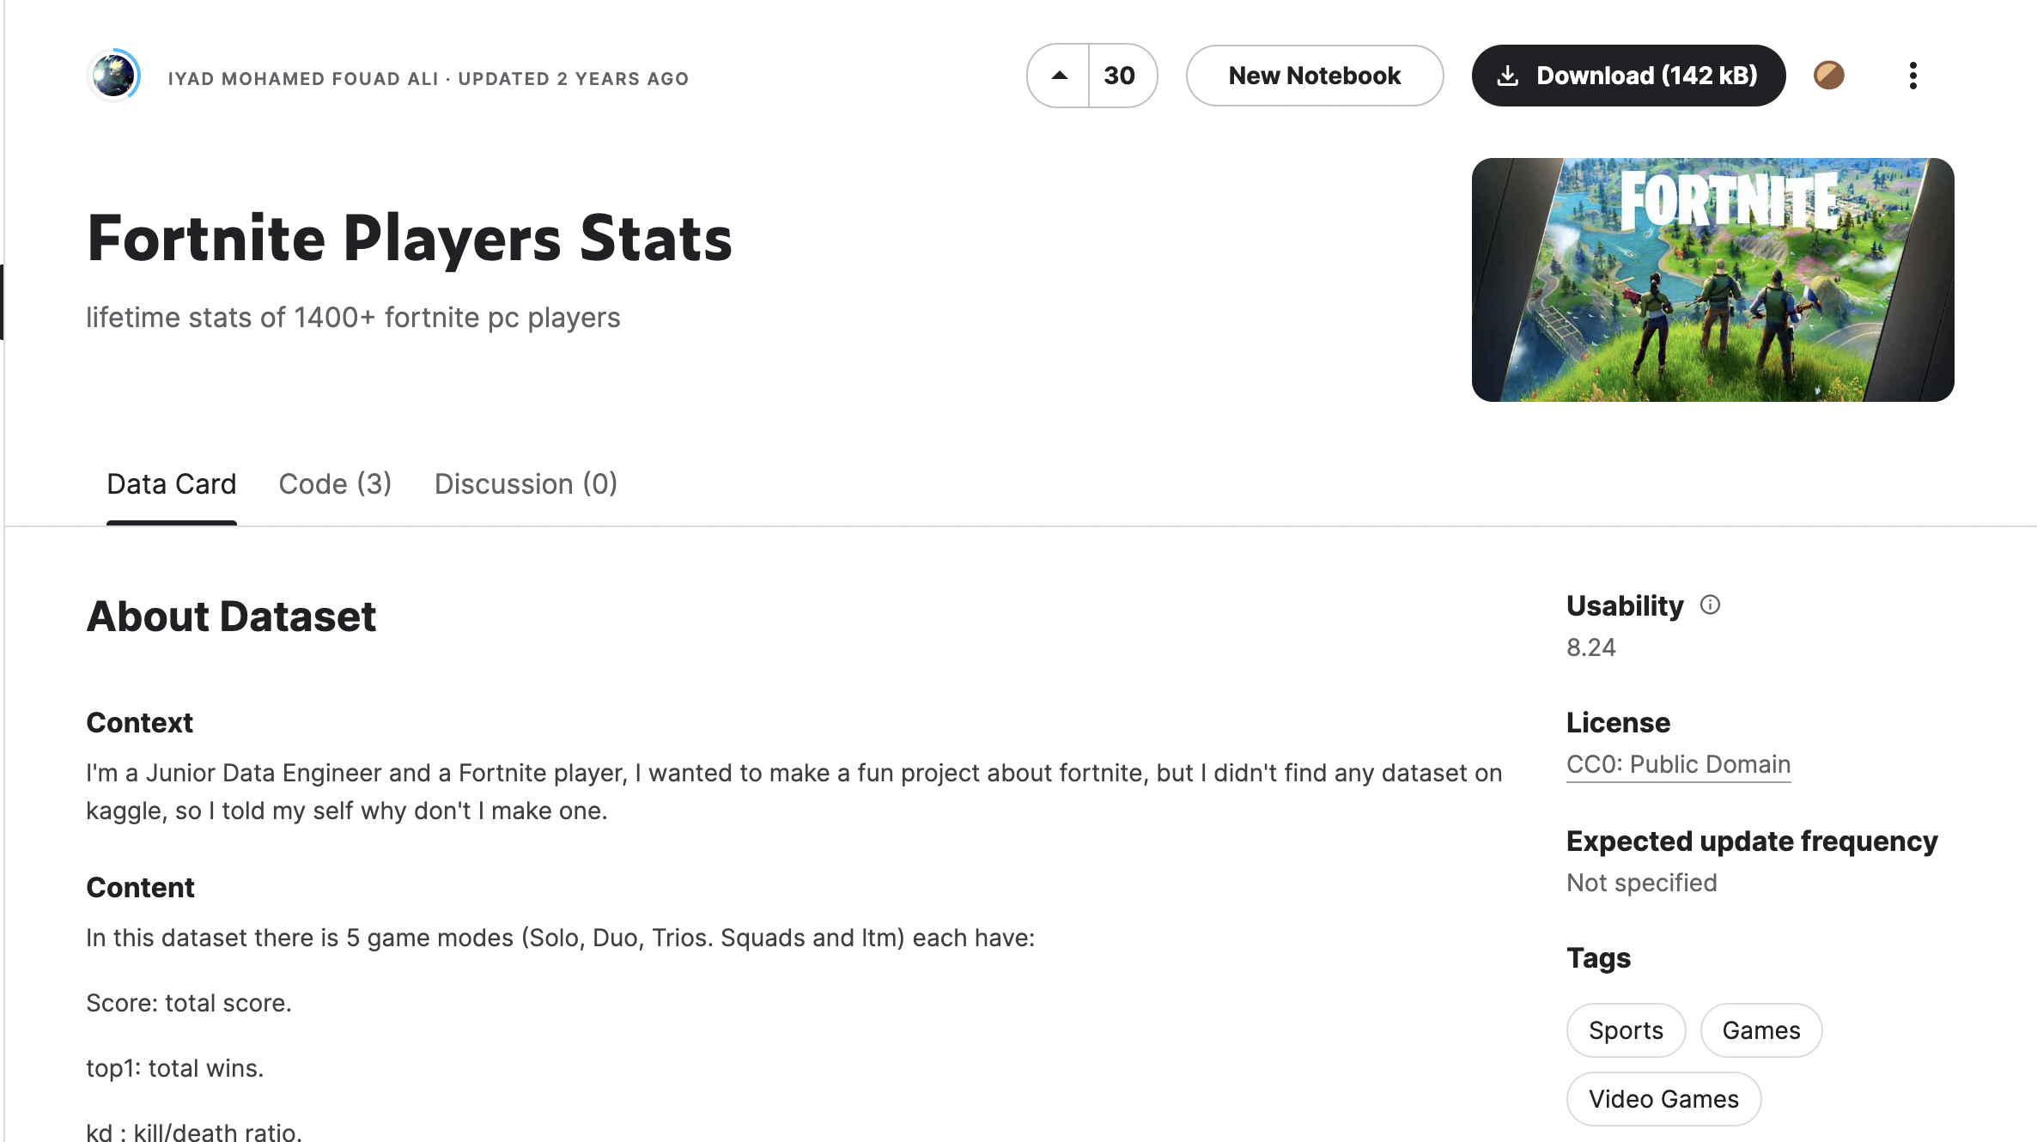

## Data preparation

It was in a clean format however after checking for the missing values I found that there are missing data points for Trio, LTM and squad game modes. However, as I do not need to conclude data points for these attributes because my research question solely represents the performance of players in just one game mode which is Solo matches.

Data points for the data set Fortnite_Player_stats = 1435

|  |
| --- |
| Player |
| String |

|  |  |  |  |  |  |  |
| --- | --- | --- | --- | --- | --- | --- |
| Solo score | Solo top1 | Solo kd | Solo winRatio | Solo matches | Solo kills | Solo minutesPlayed |
| Numerical | Numerical | Numerical | Numerical | Numerical | Numerical | Numerical |

|  |  |  |  |  |  |  |  |
| --- | --- | --- | --- | --- | --- | --- | --- |
| Dous score | Duos top1 | Duos k/d | Dous winRatio | Duos matches. | Duos kills. | Dous minPlayed | |
| Numerical | Numerical | Numerical | Numerical | Numerical | Numerical | | Numerical |

|  |  |  |  |  |  |  |
| --- | --- | --- | --- | --- | --- | --- |
| Trio’s score | Trios top1 | Trios kd | Trios winRatio | Trios’ matches | Trios kills. | Trios  minutesPlayed |
| Numerical | Numerical | Numerical | Numerical | Numerical | Numerical | Numerical |

|  |  |  |  |  |  |  |
| --- | --- | --- | --- | --- | --- | --- |
| Squads  score | Squads  top1 | Squads  kd | Squads  winRatio | Squads  matches. | Squads  kills | Squads  minutesPlayed |
| Numerical | Numerical | Numerical | Numerical | Numerical | Numerical | Numerical |

|  |  |  |  |  |  |  |
| --- | --- | --- | --- | --- | --- | --- |
| LTM score | LTM top1 | LTM kd | LTM winRatio | LTM matches. | LTM kills. | LTM  minutesPlayed |
| Numerical | Numerical | Numerical | Numerical | Numerical | Numerical | Numerical |

Every attribute represents different statistics about each player as screenshotted and mentioned. these different attributes represent the score of each player, what players got top1 in different game modes, the KD of the players, the win ratio of players, the matches they played, how many kills they got and the minutes each player has played in different game modes.

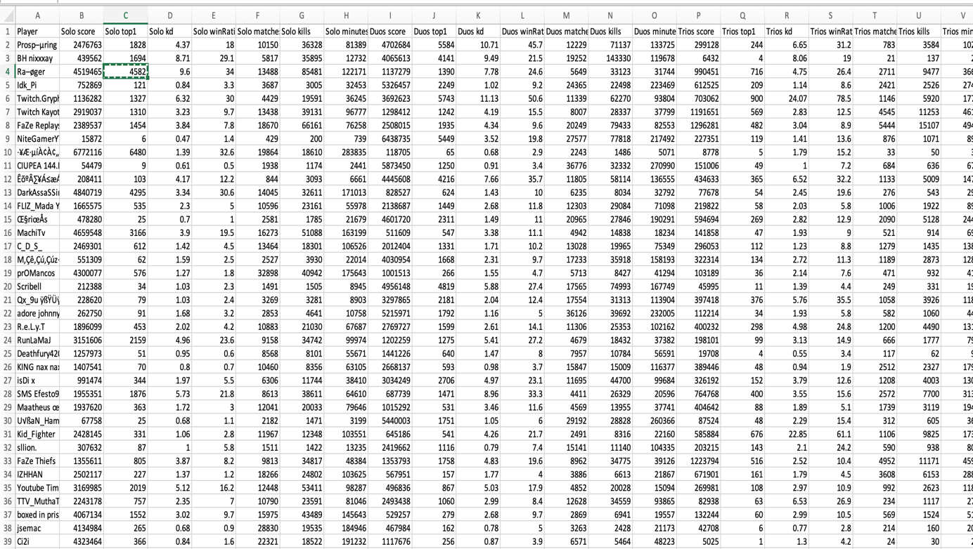

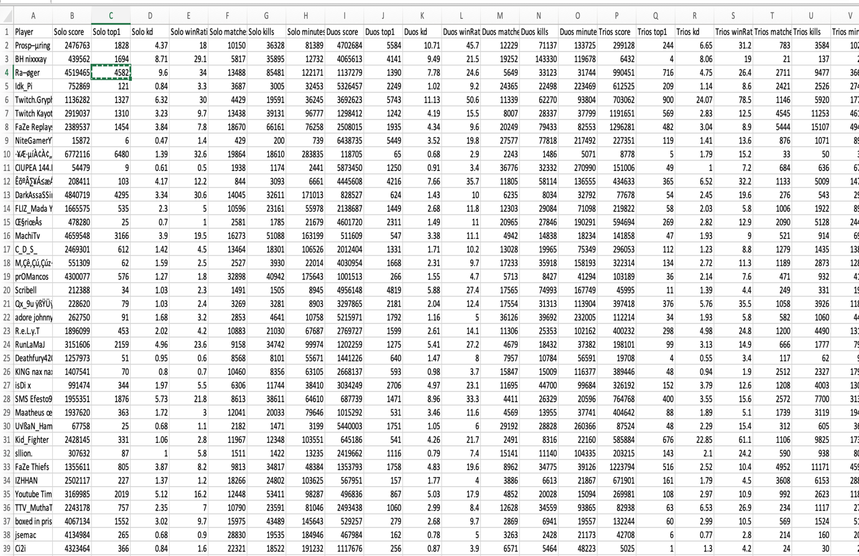

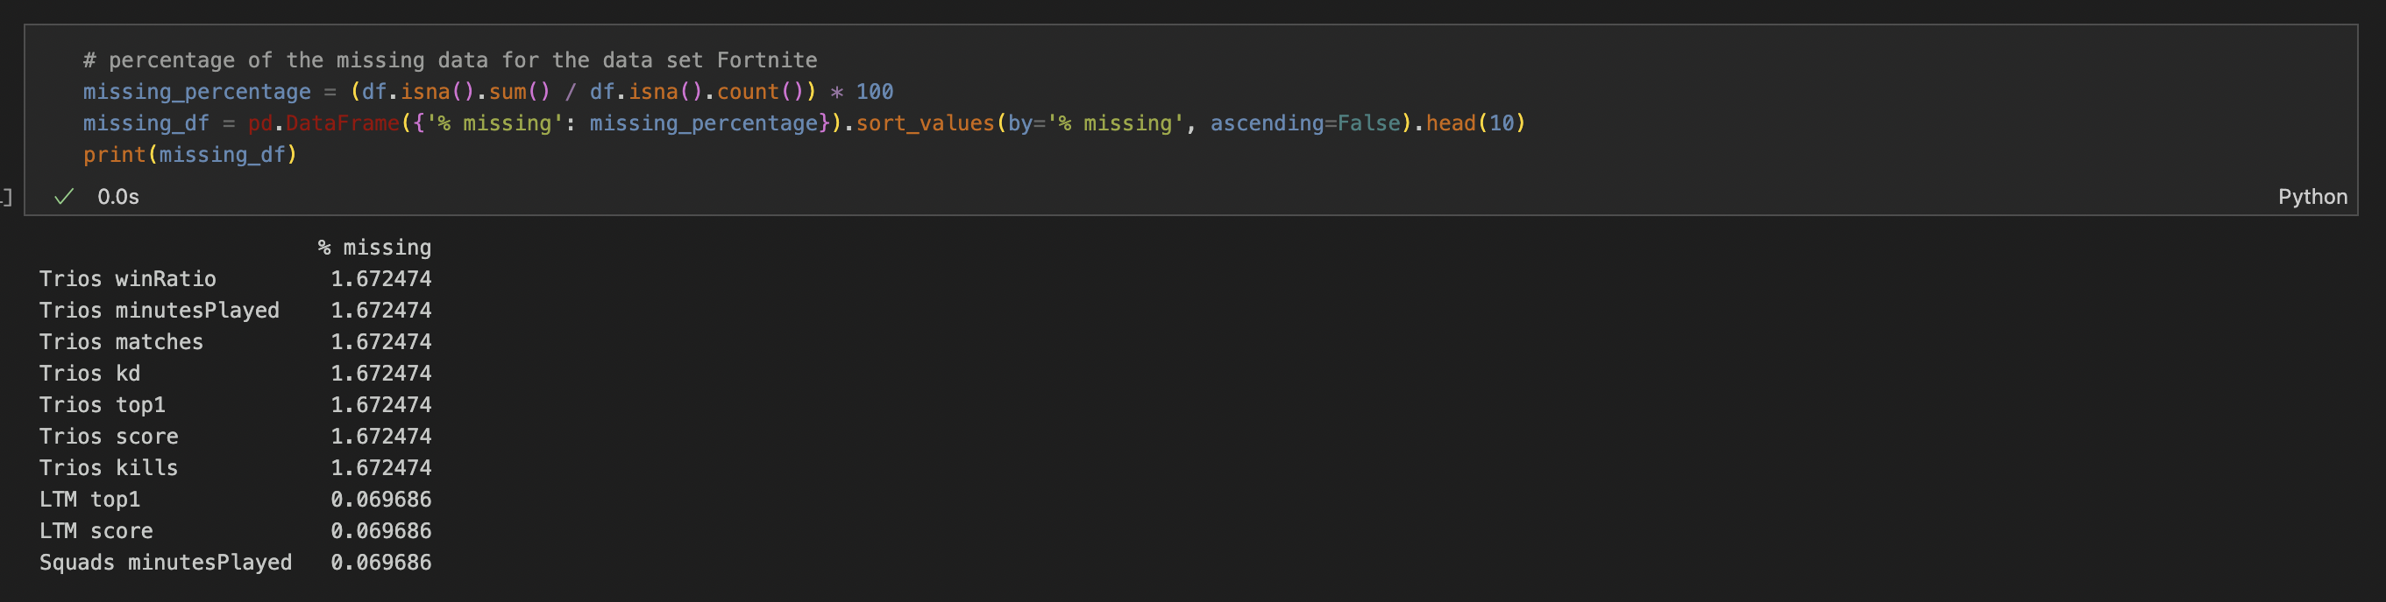

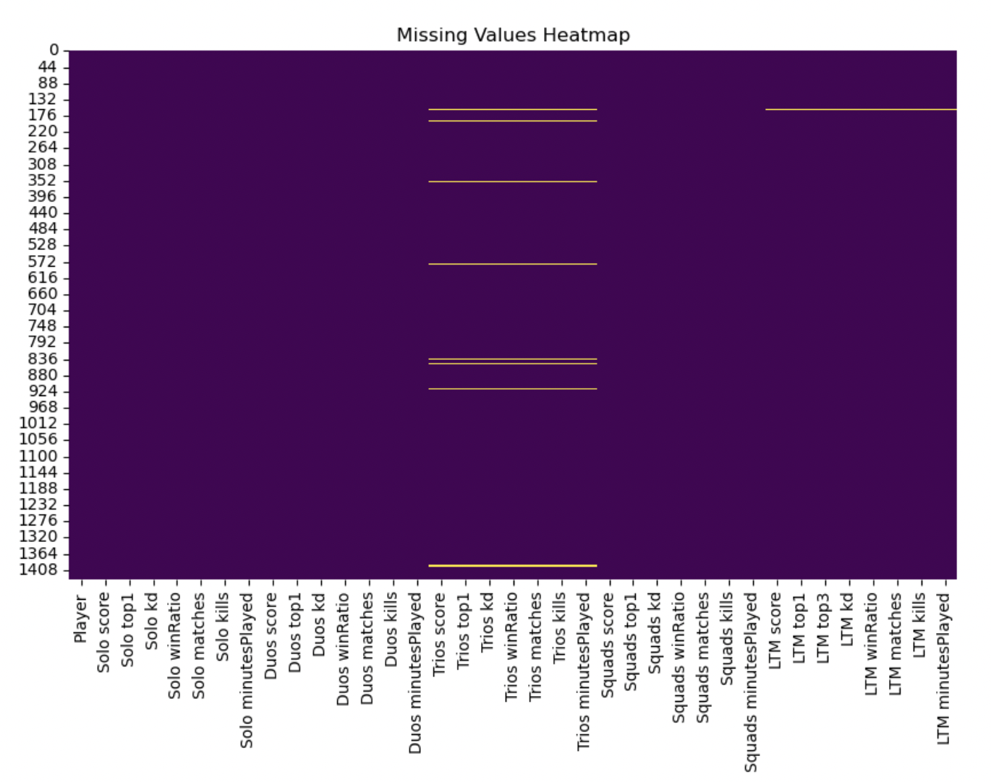

Missing values for the data set and I have used python.

After this I have filtered to find the best top 50 players in Solo game mode using the solo score which is the attributes that has the elements that explains every performance of these top 50 players in one single Solo game mode. A players overall score has a very big impact on how they perform in very intensive games such as Fortnite final cup tournament

Solo score = this shows the top 50 solo scores

Players = the names of the players

Solo winRatio = shows the win ratio of top 50 players

Solo Kills = shows the kills of every top 50 player

Solo KD = this shows the kill/death ratio of every top 50 players

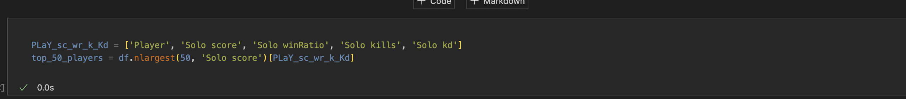

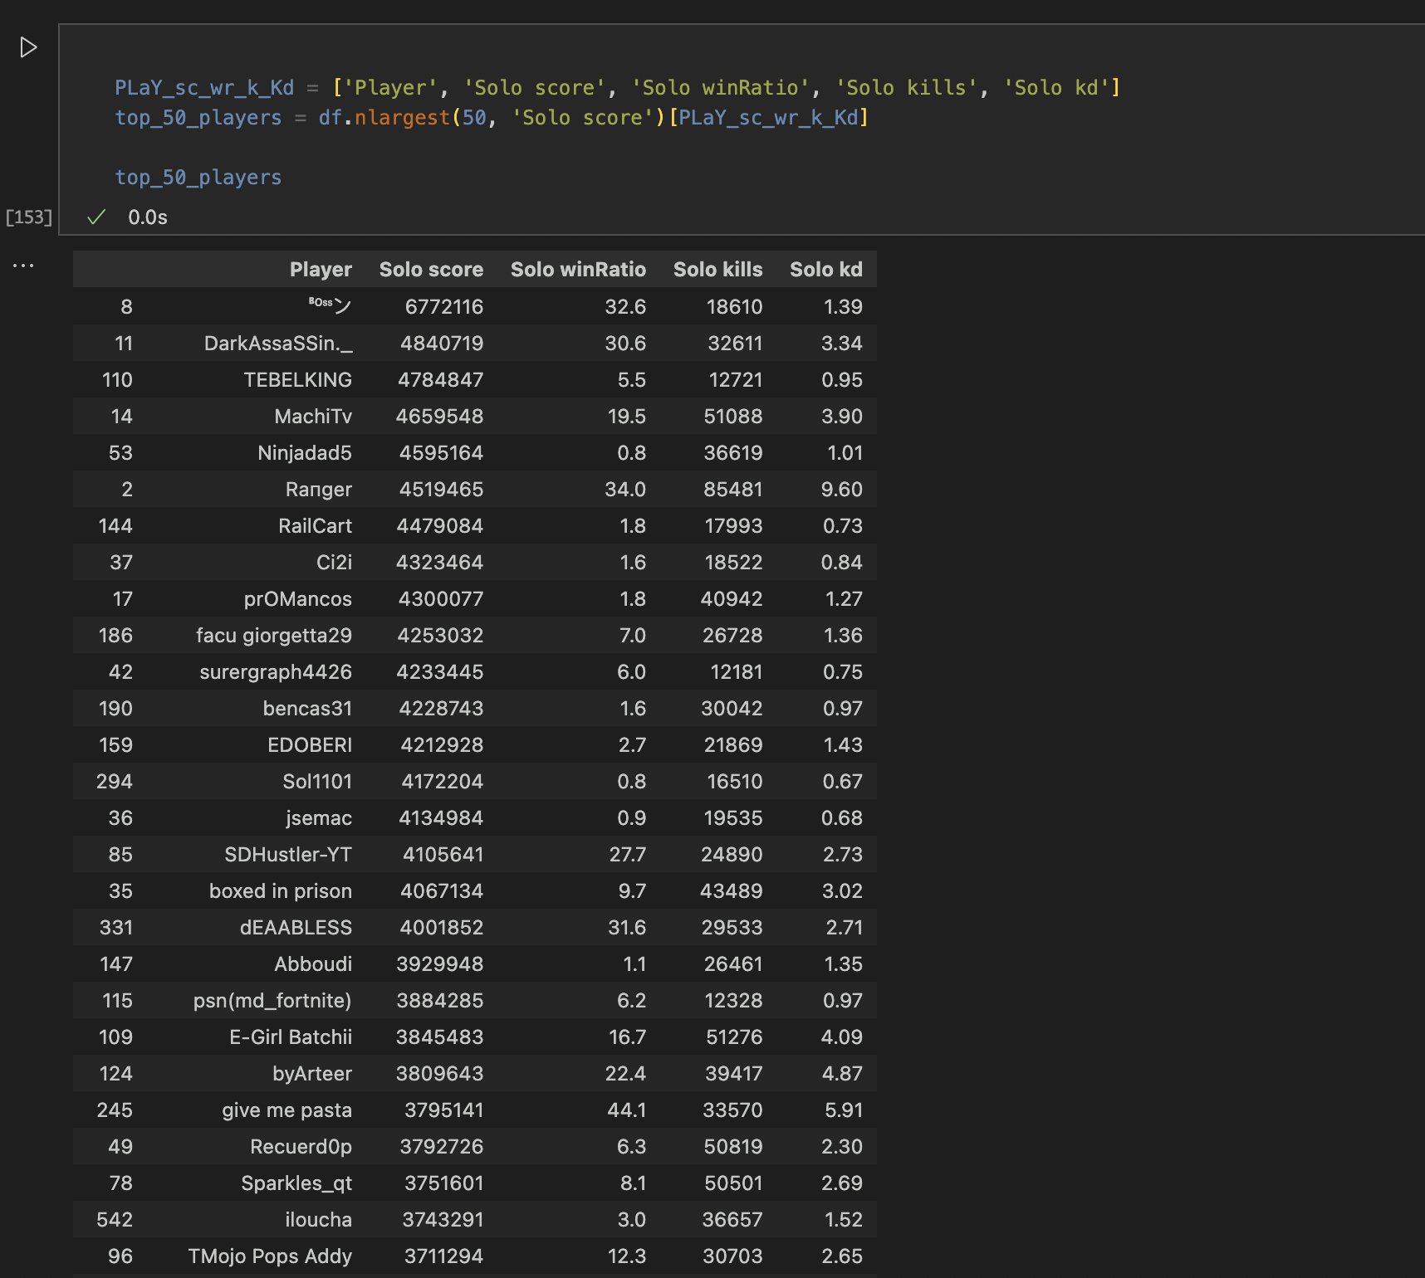

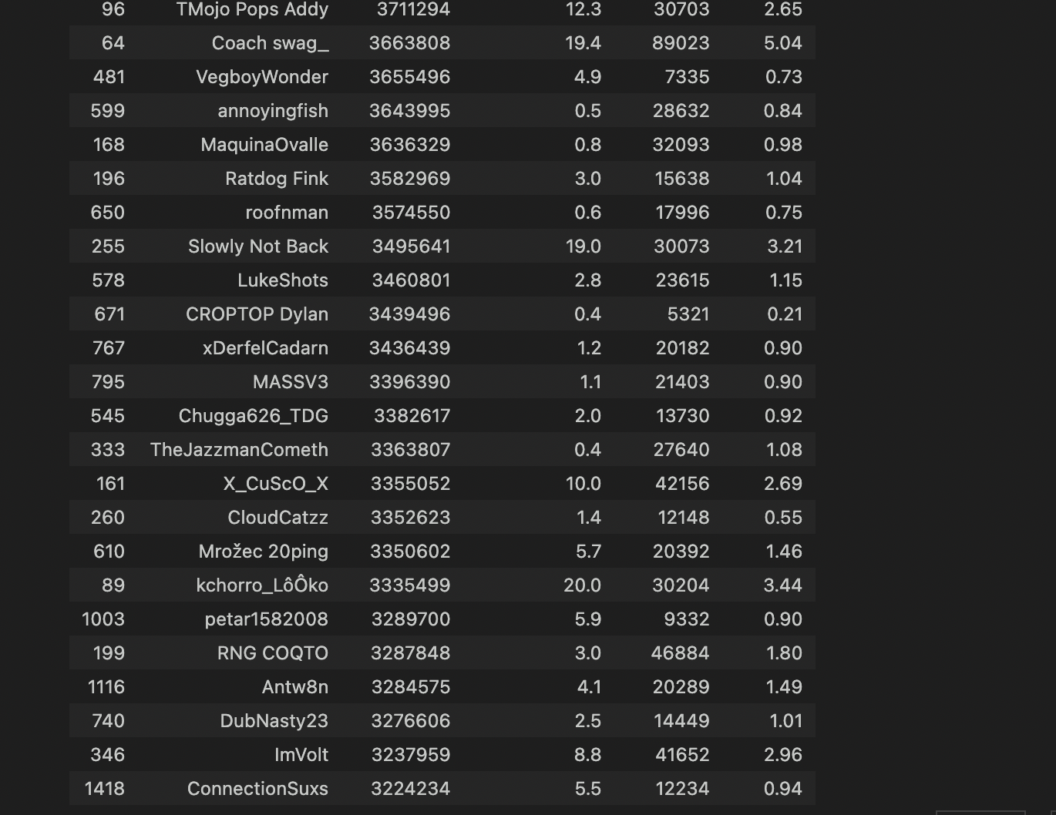

In other words, this is also called sampling the top 50 players by solo score and using the other 4 elements that helps prove that they are the top 50 best players in solo matches.

## Exploratory Data Analysis

In this part of the report, I have done multiple exploratory data analysis in python using the Fortnite player statistic data set and I have posted multiple screenshots and as well as their analysis and how these findings answer my research question.

EDA 1.1 Solo score Distribution

The distribution of the solo scores between the top 50 players is a visualisation through a histogram Model. The x-axis represents the solo score, and the y-axis shows the number of players. There is a peak at around 5.5, which means that most of the top 50 players have solo scores around 5.5. The distribution is skewed to the left, which means that there are more players with lower solo scores than there are players with higher solo scores. This graph suggests that there is a wide range of skill levels among the top 50 players. The peak at around 5.5 suggests that there is a sweet spot for solo scores, where players can consistently perform well. The left skew of the distribution suggests that there are more players who are struggling to achieve high solo scores than there are players who are naturally gifted at the game.

Here is the Histogram and the code.

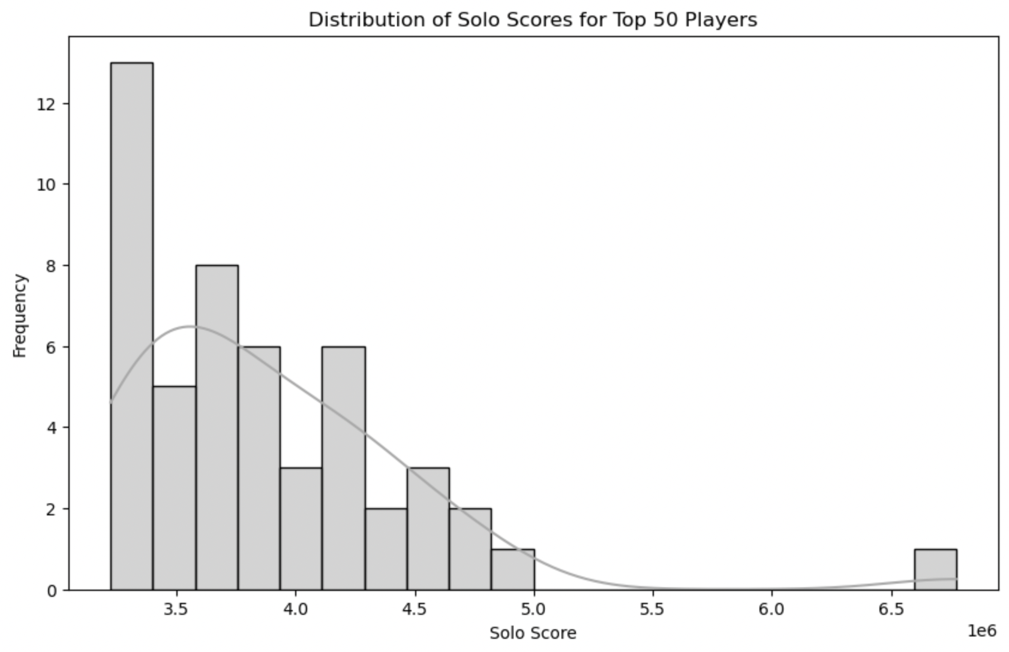

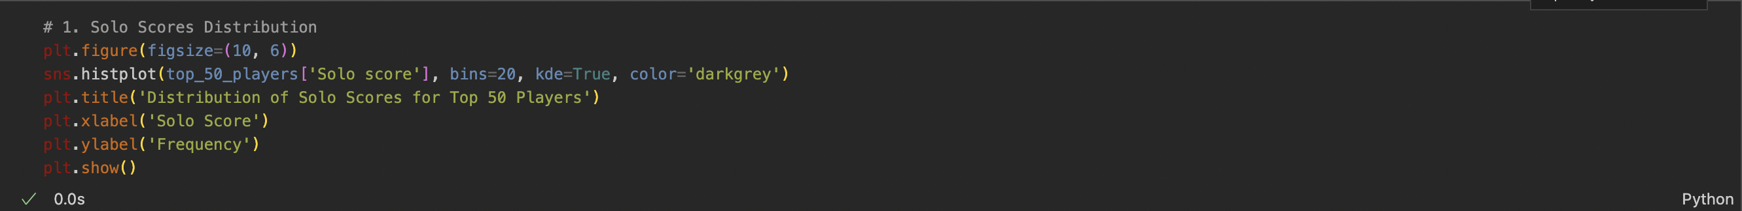

EDA 1.2 Solo win Ratio Distribution

This distribution histogram sheds a light on the win ratio frequency of the top 50 players and how they perform depending on the Win ratio of every player. The x-axis represents the solo win rate, and the y-axis shows the number of players. There is a peak at around 55%, which means that most of the top 50 players have solo win rates around 55%. The distribution is slightly skewed to the left, which means that there are more players with lower solo win rates than there are players with higher solo win rates. This graph suggests that the top 50 players are all very skilled, but there is still some variation in their win rates. The peak at around 55% suggests that there is a natural limit to how high a player's solo win rate can be. The left skew of the distribution suggests that there are more players who are struggling to achieve high win rates than there are players who are naturally gifted at the game. This is a crucial part of the insight as it shows how win ratio has the impact on each player’s overall score.

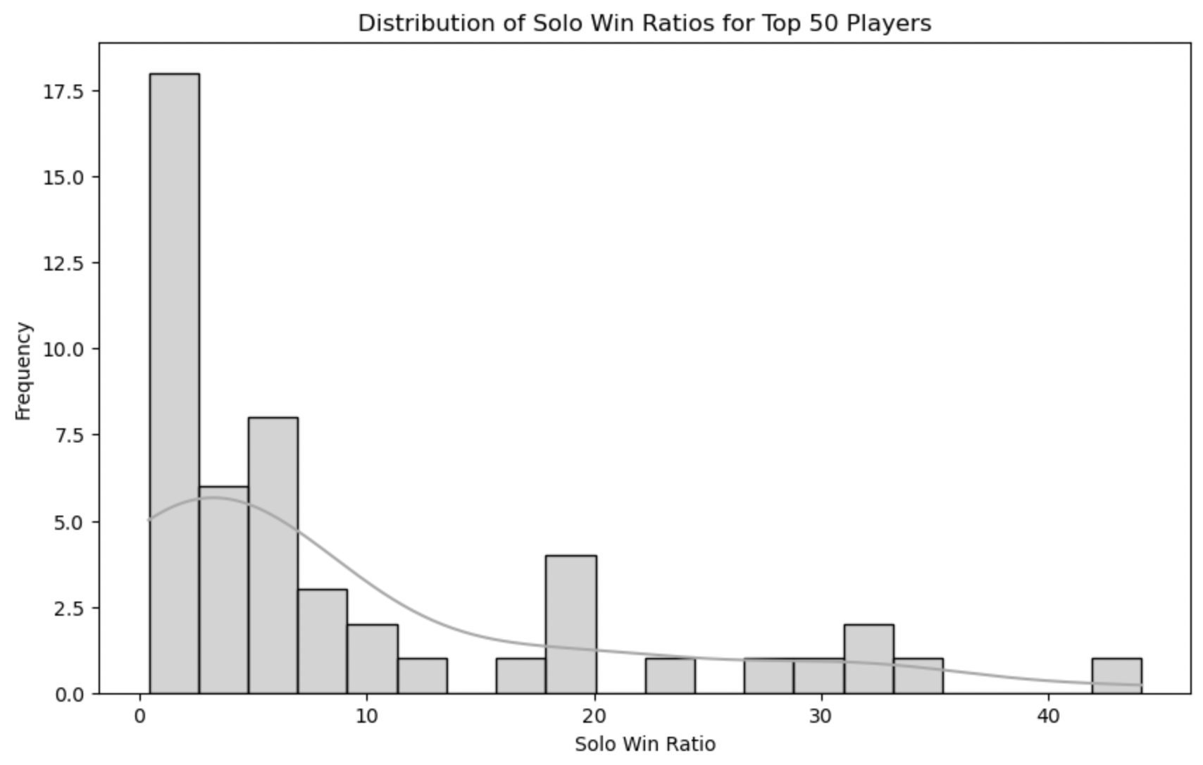

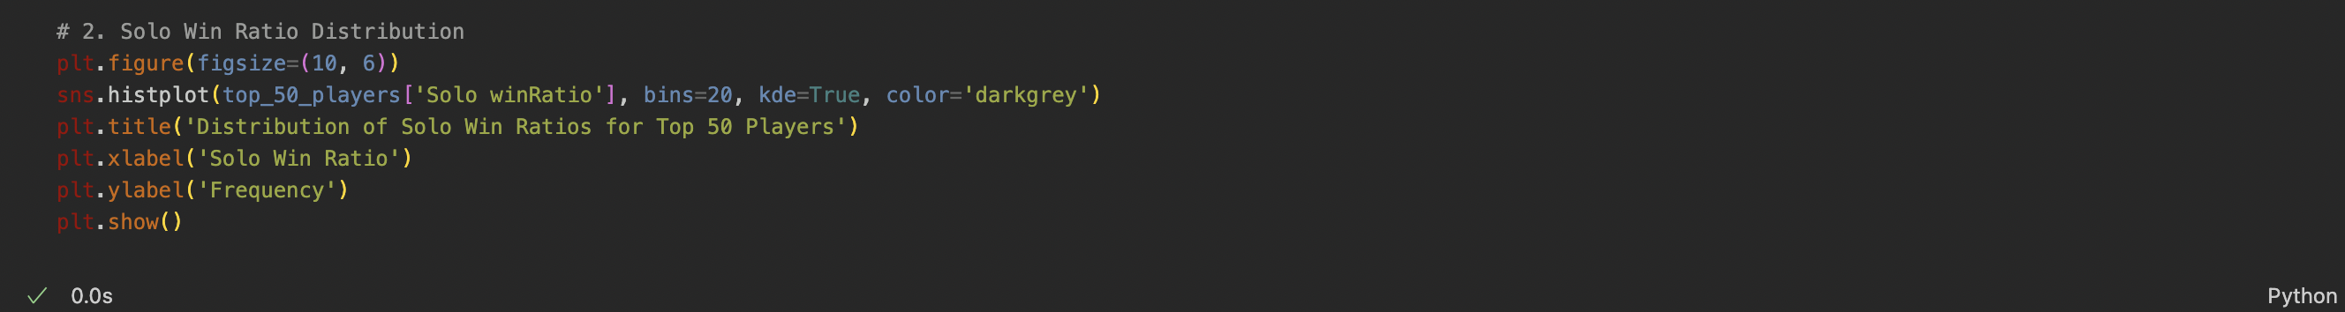

EDA 1.3 Solo Kills Distribution  
The graph shows that most of the top 50 players have win rates around 55%. This means that the top players are all very skilled, but they are not that different from each other in terms of win rate. There are a few players who have win rates above 70%, but there are many more players with win rates below 50%. These players are likely still learning the game or not as skilled as the top player This is also one of the crucial parts of the data set as it provides an element that gives an understanding of how a players improve over time.

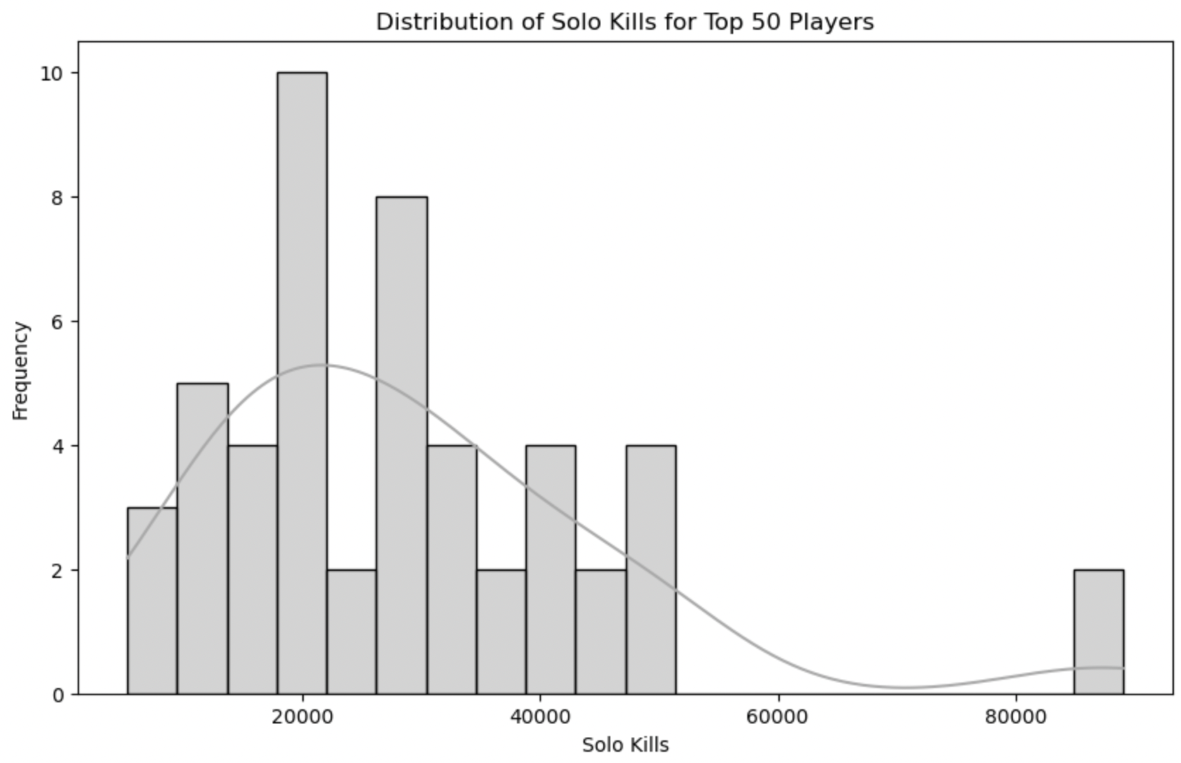

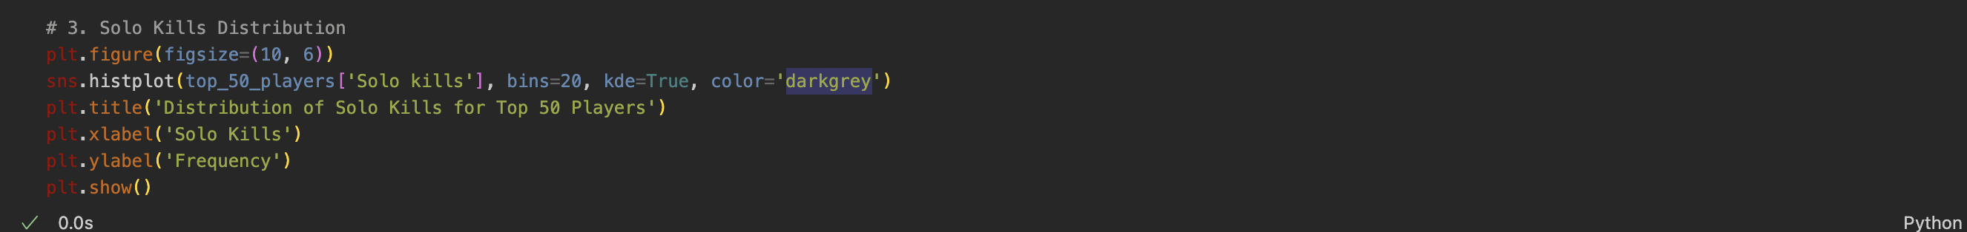

EDA 1.4 Solo KD Distribution

The graph shows that the vast majority of the top 50 players have a K/D ratio of around 2.5. This means that they manage to get more kills than they have deaths on average. The few players with very high K/D ratios are likely to be highly skilled and aggressive players, while those with low K/D ratios are likely to be newer players or players who prefer to play more defensively. This also has an impact on the overall score of these 50 players as this can help them prove themselves that they are the best.

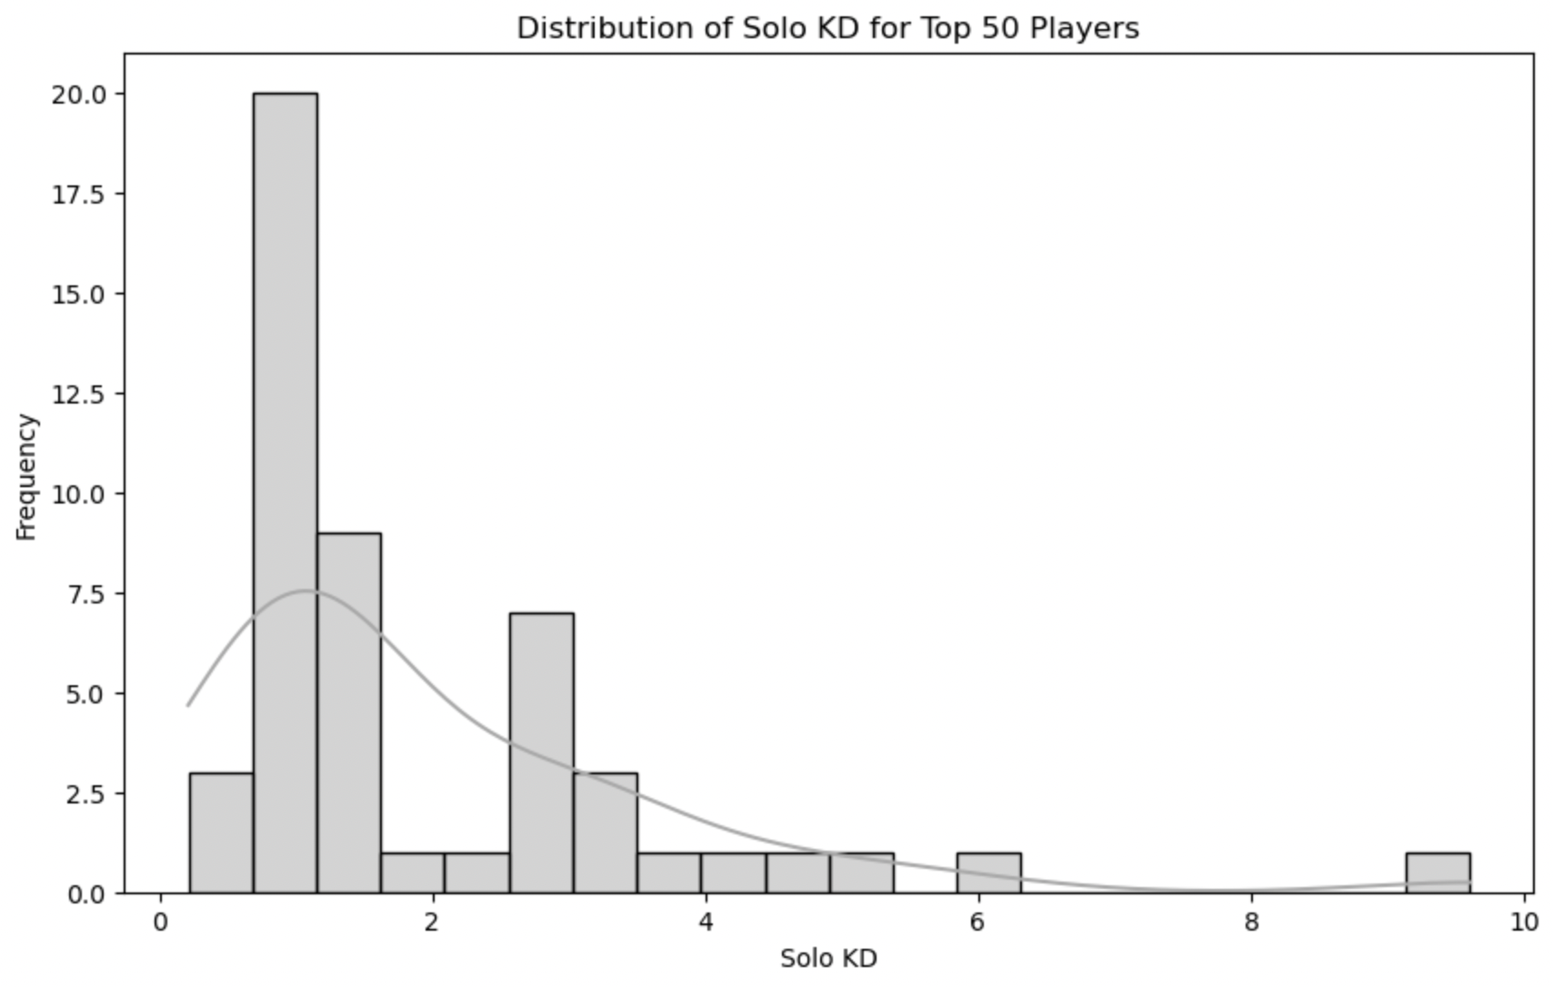

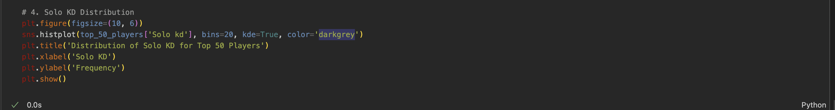

EDA 1.5 a pair plot for numerical features

This pair plot graph demonstrates and explores the potential relationship between the numerical features, allowing for a very comprehensive and deep analysis of their interactions. This visualisation allows for a quick assessment of the correlations and patterns and the distribution among the 50 chosen best players in solo performance. This also shows the potential of these 50 best players. Most players (around 30%) have scores between 5.0 and 6.0, indicating moderate performance. However, a significant portion (around 20% each) fall below 5.0 and above 6.0, suggesting a diverse skill range.The peak at 5.5 represents the average or 'sweet spot' for solo scores. The left skew indicates a higher concentration of players with lower scores compared to those with higher ones. This implies that achieving exceptional solo scores is more challenging.

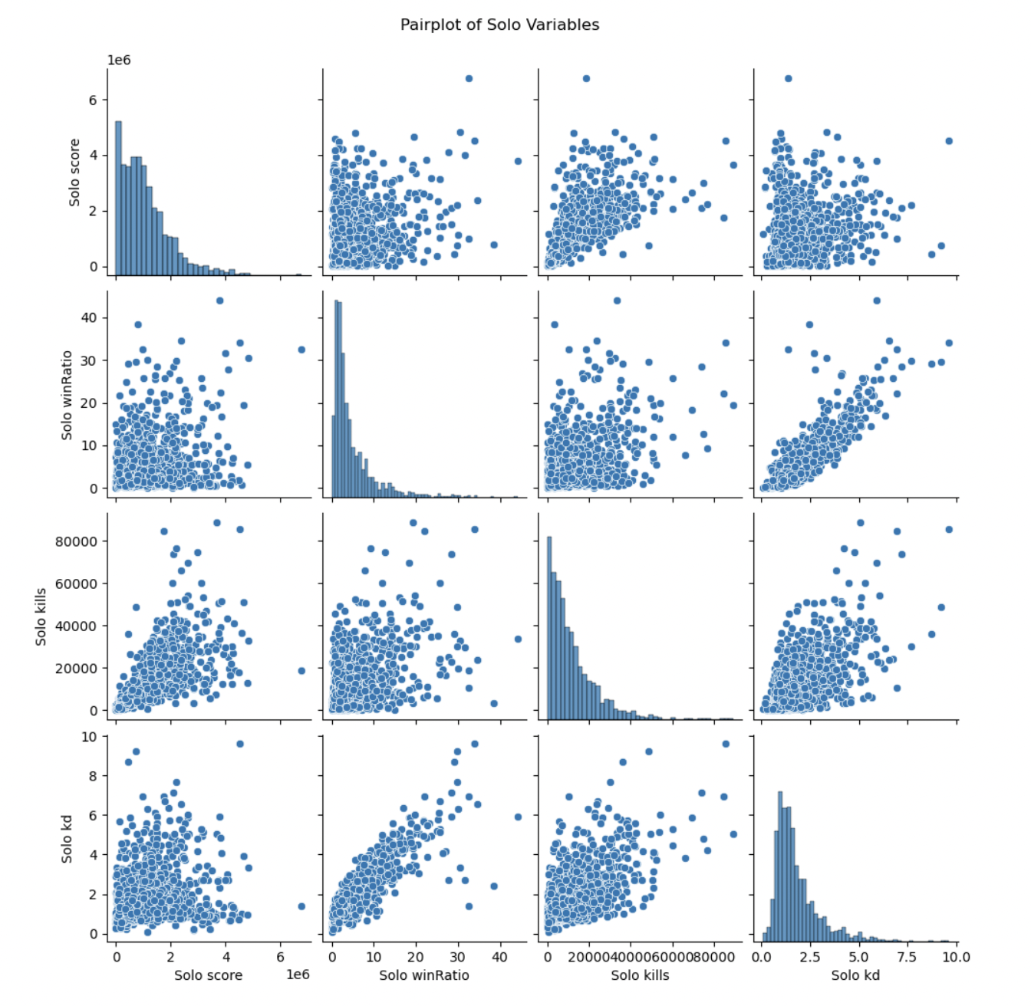

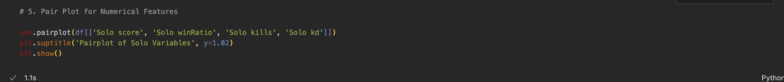

EDA 1.6 Correlation Heatmap

This Heat map visualise a very important representation of the relationship. Also showcases the strong correlation between the two metrics, indicating that players with higher solo scores are also more likely to win their games. Players with solo scores exceeding 6.0 hold a win ratio above 60%, while those with solo scores below 5.0 struggle to maintain a win ratio above 50%. This suggests that solo score serves as a reliable indicator of success in solo games. Players aiming to enhance their win ratio should prioritize improving their solo score.

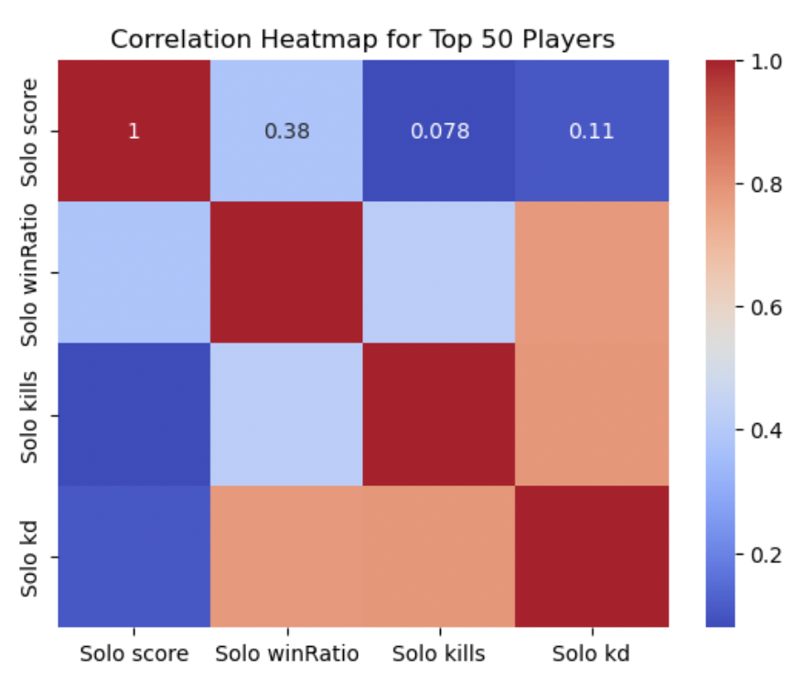



EDA 1.7 Box plot for Solo score

The Box Plot visualisation method shows the potential outliers in just the top solo scorers of Fortnite solo game. The reason why this is utilized is because it also shows the potential performance of the players. The brighter the colour grey, the stronger the correlation. As observed, there is a strong positive correlation between solo score and solo win ratio, indicating that players with higher solo scores are more likely to win their games. For instance, players with solo scores above 6.0 have a win ratio above 60%, while players with solo scores below 5.0 have a win ratio below 50%. Overall, the heatmap suggests that solo score is a reliable predictor of success in solo games, and players who want to improve their win ratio should focus on improving their solo score.

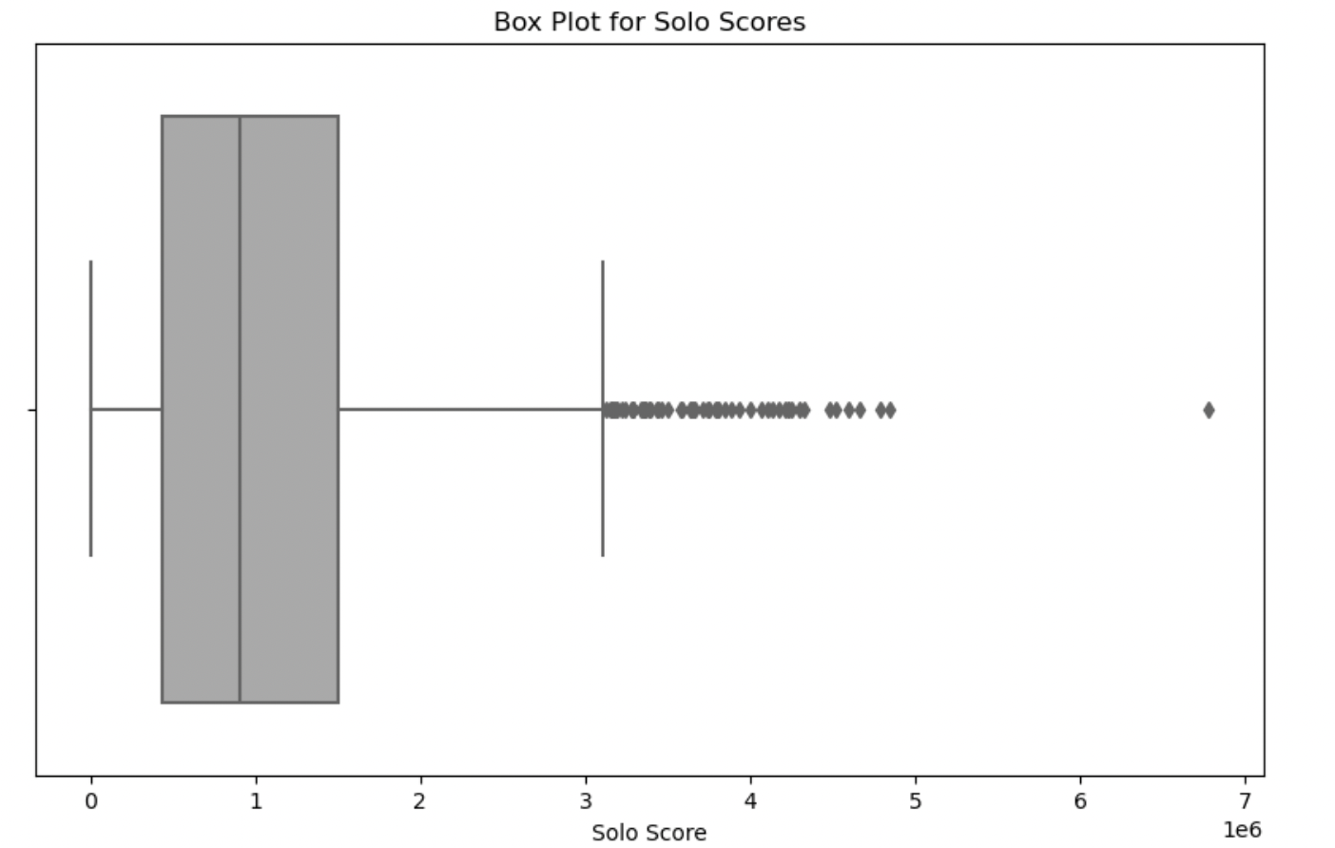

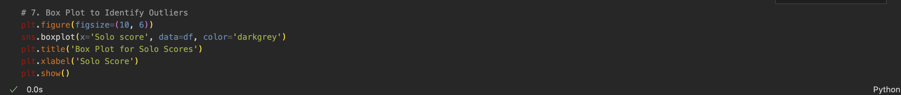

## Data Story telling

Embarking on the journey through the data landscape of the top 50 solo players in Fortnite, each data point is deciphering the secrets of the elite gaming. The initial root of analysis starts with Solo score distribution where numerical figures become more than data points. They have become the heartbeat of an intense gaming competition among the best 50 in Solo game mode.

Transitioning from the world of numbers or narrative it changes into a Win Ratio distribution where there is a visual representation that underscores the strategic prowess setting these best players apart. The histogram shows the depicting a high Win Ratio defining elements.

The exploration of the Solo Kill distribution takes the centre stage. A histogram demonstrates the aggression and the combat proficiency exhibited by the top 50 players. Beyond victories representing a significant kill count in each game they play. This visualises their skills and in-game performance.

another layer in this story is the exploration of the Solo Kill/Death ratio that revealed the players efficiency in combat and survival mode. One of the critical aspects in the solo game mode where every encounter holds a profound significance. The KD emphasises the offence and the defence of players, so the histogram represents the skills that the top 50 players must be the best in their field.

The pair plot method send for the numerical features emerges a visual representation of the interactions between different performance matrices., Within the solo Score, Win Ratio, KD, kills correlations and patterns swiftly come to light. This exploration of these elements helps to profile the top 50 best players.

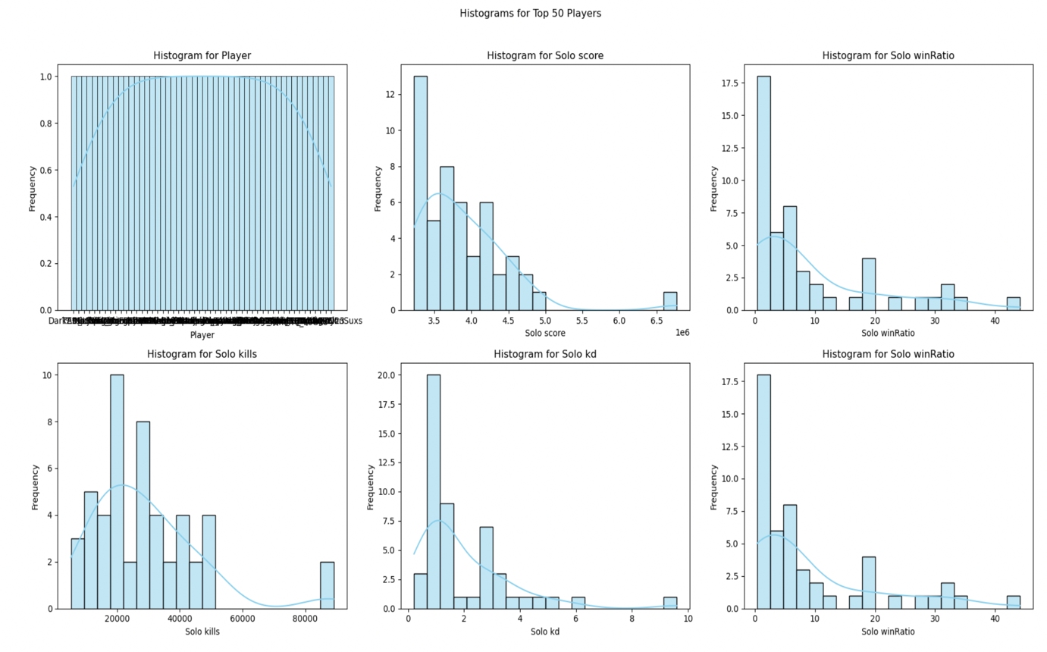

The box plot for Solo Score unveils potential. Outliers among the top 50 which each outlier emerges from as a distinctive tale. This is a showcasing reel which is the exceptional performances that set certain players apart. Each whisker in the boxplot method becomes a brushstroke adding a additional layer of intrigue into the narrative.

In conclusion, this data exploration encapsulates the essence of the elite gaming among the best 50 solo players in Fortnite. The Solo Scores distribution, Win Ratio, Solo Kills Distribution, Pair Plot, Correlation Heatmap, and the Box Plot collectively weave a way into finding numerical confines. The exploration not only directly address the research question but also imparts valuable insights into the diverse skills and intricate strategies that collectively contribute to the unparalleled success of these players in the challenging game of Solo.

In answering the research question, the narrative unfolded through a series of visual representation that provides the information and the insight of the connected elements that have the biggest contribution towards the best 50 players overall performance. From the showcase of the Solo Score distribution that shows their competitiveness spirit to the Win ratio distribution highlighting strategic moves the visual journey continues through to Solo kills, KD all the way to their kills.